**UNIT-III**

# Building a Quantum Computer – Theoretical Challenges and Requirements

# What is required to build a quantum computer (conceptual overview)?

Building a quantum computer involves several complex steps, requiring expertise in quantum mechanics, computer science, electrical engineering, and various other fields.

Below are the key components and steps needed to build a basic quantum computer:

# Choose a Quantum Computing Model

Here are some of the most widely used quantum computing models:

**Superconducting qubits:** These qubits are made from superconducting circuits and are controlled by microwave pulses. This is the approach used by companies like SpinQ, IBM, and Google.

**Trapped ions:** Individual ions are trapped using electromagnetic fields and manipulated with lasers to perform quantum operations.

**Photonic qubits:** Quantum states are encoded in photons, and quantum operations are performed using optical elements.

**Topological qubits:** This approach leverages quantum states that are resistant to local disturbances, aiming to make qubits more stable.

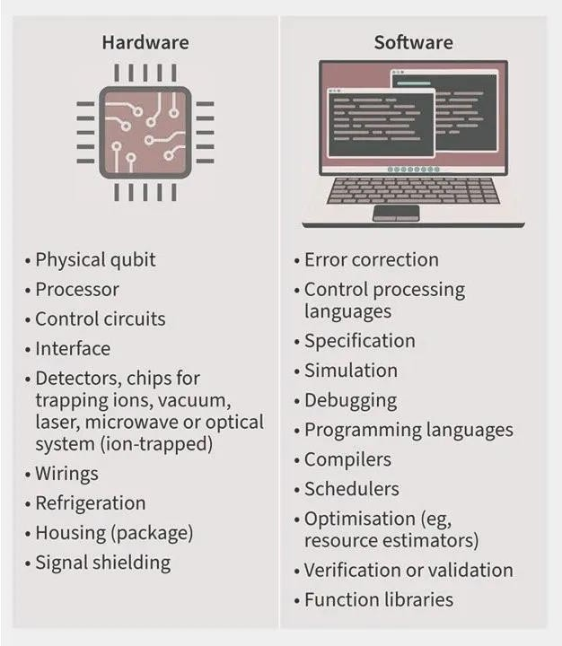

# Create Qubits

Qubits are the fundamental units of a quantum computer. The choice of qubit technology (e.g., superconducting qubits, trapped ions, photonic qubits) will determine the approach for their creation. Each qubit should be:

**Quantum coherent:** The qubits need to maintain their quantum state for a long enough period to perform quantum calculations.

**Entangled:** One of the key aspects of quantum computing is entanglement, where qubits can be correlated in a way that their states depend on each other.

# Quantum Gates and Circuits

A quantum computer performs operations using quantum gates, which are analogous to classical logic gates but work on quantum bits. The quantum gates manipulate the qubits to perform quantum algorithms.

**Single-qubit gates** like X, Y, Z, Hadamard, and Phase gates modify the state of a single qubit.

**Multi-qubit gates** like the CNOT (Controlled NOT) gate entangle multiple qubits and enable more complex operations.

# Quantum Control Systems

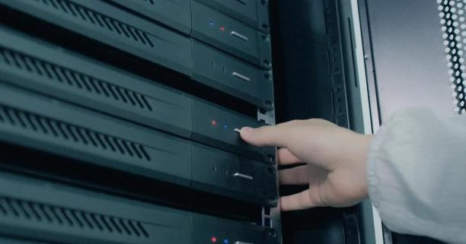

Quantum computers require advanced control systems to manage qubits and quantum gates. These systems include:

**Signal generation and amplification** for manipulating the qubits using electromagnetic pulses or lasers.

**Cryogenics (for certain qubit types):** Superconducting qubits require extremely low temperatures (near absolute zero) to operate, so cryogenic systems (such as dilution refrigerators) are necessary.

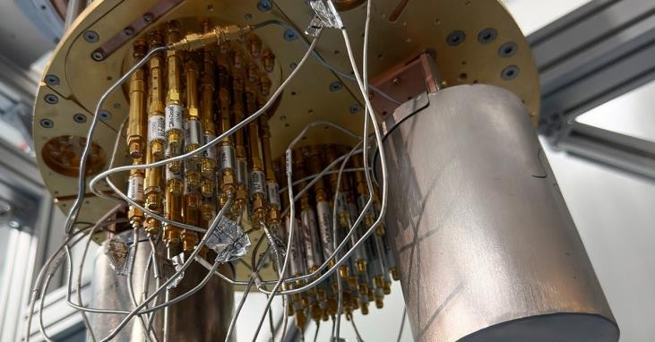

# Quantum Error Correction

Quantum systems are highly susceptible to errors due to decoherence and noise from the environment. Implementing quantum error correction is essential to ensure reliable computation.

Various error correction codes are used, such as surface codes or concatenated codes, but they require additional qubits and operations, which makes the system more complex.

# Quantum Algorithms

After building the hardware, quantum algorithms are the next step. Famous quantum algorithms include:

**Shor's algorithm** for factoring large numbers, which has implications for cryptography.

**Grover's algorithm** for searching unsorted databases more efficiently than classical computers.

Algorithms for simulation of quantum systems, optimization problems, machine learning, etc.

# Develop Quantum Software

Software frameworks, such as **SpinQit (SpinQ), Qiskit (IBM), Cirq (Google),** provide programming environments for writing quantum algorithms. These tools allow you to simulate quantum circuits before implementing them on actual quantum hardware.

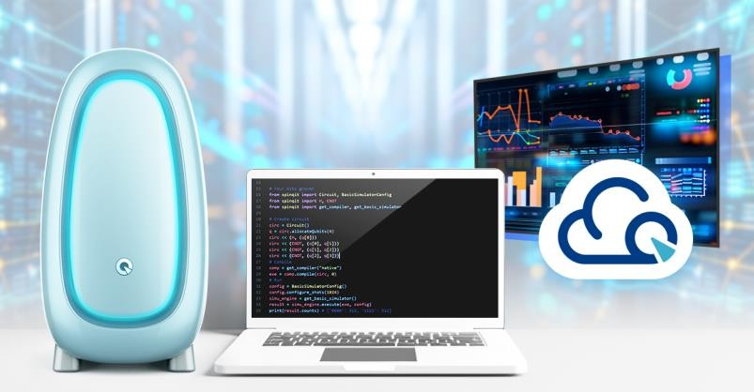

# Testing and Scaling

Testing is crucial in a quantum computer, as errors are common, and even small imperfections can lead to incorrect results. The process involves verifying that the qubits behave as expected and running small test programs to ensure that they operate within the desired tolerance.

Scaling quantum computers involves adding more qubits and ensuring that they can maintain coherence over time, which is a significant challenge.

# Interfaces and Connectivity

Once the quantum computer is functional, it must be connected to classical computers for input/output operations. Quantum computers require classical systems for handling communication, controlling qubit manipulation, and processing results.

# Challenges in Building Quantum Computers

**Quantum decoherence:** Qubits lose their quantum state due to interactions with their environment.

**Scalability:** It's difficult to build large-scale quantum computers, as adding qubits often increases the complexity and likelihood of errors.

**Error rates:** Quantum gates need to be applied with high precision, and any error can compromise the outcome.

Building a quantum computer is a multidisciplinary endeavor, combining quantum theory with cutting-edge engineering. Each quantum computer design has unique challenges and trade-offs, depending on the qubit technology and the specific goals of the quantum machine.

# Can I Build a Quantum Computer at Home?

In short, no, you cannot build a quantum computer at home due to the complex hardware and specialized equipment required, such as cryogenic systems, lasers, and high- precision control mechanisms. These systems need to be operated in controlled lab environments, and the cost and expertise involved are beyond home setups.

However, if you're interested in simulating quantum computing and experimenting with quantum algorithms, you can build a quantum "computer" at home using quantum simulators like SpinQit or accessing cloud-based quantum computing platforms.

# Here are the basic steps:

1. Install a Quantum Computing Programming Framework like SpinQit
2. Start Writing Quantum Algorithms
3. Use Cloud-based Quantum Computers
4. Experiment with Quantum Simulators

While you can't build a real quantum computer at home, you can gain hands-on experience with quantum algorithms, quantum circuits, and quantum simulations. This is the most practical approach to quantum computing for hobbyists and students.

# How Long Does It Take To Build a Quantum Computer?

The timeline to build a quantum computer depends on the specific type of quantum computer and its intended use (e.g., research, commercial, or scalable systems).

However, building a fully functioning, large-scale quantum computer is still in the early stages.

**Short-Term (2-5 years):** For small-scale, specialized quantum computers or prototypes, such as those developed by companies like SpinQ, and IBM, it could take 2 to 5 years to refine and improve the existing systems, especially for educational quantum computers or cloud-based applications.

**Long-Term (10+ years):** Building a truly large-scale, fault- tolerant quantum computer capable of outperforming classical computers (known as "quantum supremacy") may take 10 or more years.

Many experts believe that scaling quantum computers to solve practical and complex problems will require significant advancements in quantum error correction and qubit stability.

**How Much Does It Cost to Build a Quantum Computer?** The cost of building a quantum computer is currently extremely high due to the specialized equipment, technologies, and expertise required.

# Small-Scale Quantum Computers (Research and Prototypes):

These can cost anywhere from several million to tens of millions of dollars, depending on the qubit technology (e.g., superconducting qubits, trapped ions), as well as the complexity of the system (including control and measurement systems, cryogenics, and lasers).

# Large-Scale Quantum Computers:

A fully operational, large-scale quantum computer with thousands of qubits and advanced error correction may cost hundreds of millions of dollars to develop and maintain. The associated costs include not only hardware but also the labor involved in designing, testing, and scaling the quantum system.

# Ongoing Operational Costs:

Additionally, maintaining quantum computers is expensive. For example, superconducting qubits require cryogenic

environments (extremely low temperatures) which can be costly to operate and maintain.

# Fragility of quantum systems: decoherence, noise, and control

Quantum systems are inherently fragile due to their sensitivity to the environment, leading to decoherence, noise, and requiring careful control. Decoherence, the loss of quantum information due to interaction with the environment, and noise, unwanted fluctuations that disrupt quantum states, are major challenges in building stable quantum computers. Effective control strategies are crucial for mitigating these effects and preserving quantum coherence during computation.

# Decoherence:

Quantum systems rely on superposition and entanglement, states that are easily disrupted by interactions with the environment. This interaction causes the system to lose its quantum properties, transitioning from a superposition to a definite classical state, a process known as decoherence.

# Noise:

External factors like electromagnetic fields, vibrations, and temperature fluctuations can introduce noise into quantum systems. This noise manifests as unwanted energy shifts or phase changes, disrupting the delicate quantum states and leading to errors in computation.

# Control:

To counteract decoherence and noise, researchers employ various control techniques. These include:

**Dynamical Decoupling (DD):** DD involves applying a series of carefully timed pulses to the qubit to counteract the effects of noise and maintain coherence.

**Error Correction:** Quantum error correction codes are used to detect and correct errors introduced by noise, allowing for more reliable computation.

**Quantum Control Landscape:** This framework provides a systematic way to understand and optimize quantum control strategies, helping to find the best way to manipulate qubits while minimizing the impact of noise.

**Machine Learning:** Machine learning techniques can be used to design robust quantum control strategies that are resilient to noise and decoherence.

The fragility of quantum systems necessitates a multi- faceted approach that combines advanced materials, sophisticated control techniques, and error mitigation strategies to realize the full potential of quantum technologies.

# Conditions for a functional quantum system: Isolation, Error management, Scalability, Stability

A functional quantum system requires isolation to maintain qubit coherence, error management to correct for inherent noise, scalability to increase the number of qubits, and stability to ensure reliable operation over time.

# Isolation:

Quantum systems must be shielded from external disturbances that can cause decoherence, the loss of quantum information. Perfect isolation would allow qubits to maintain their superposition states indefinitely. Different quantum computing platforms, like trapped ions and superconducting circuits, have varying degrees of susceptibility to decoherence due to environmental noise.

# Error Management:

Quantum computations are prone to errors due to the inherent nature of quantum mechanics and the challenges of controlling qubits. Error correction codes are employed to detect and correct these errors without collapsing the quantum state. These codes often involve redundancy and complex algorithms to ensure reliable computation even in the presence of noise.

# Scalability:

Quantum computers need to be able to handle a large number of qubits to solve complex problems. Scaling up quantum systems is a significant challenge, requiring advancements in qubit technology, interconnectivity, and error correction techniques. Modular approaches, where multiple smaller systems are linked together, are being explored to overcome the limitations of building larger individual chips.

# Stability:

A stable quantum system maintains its properties and behavior over time. Factors like temperature fluctuations and electromagnetic interference can introduce instability and errors. Ensuring stable qubit control and operation is crucial for reliable quantum computation.

In essence, these four conditions are intertwined and essential for building a practical and useful quantum computer.

# Theoretical barriers: Why maintaining entanglement is difficult, Error correction as a theoretical necessity, Quantum hardware platforms (brief conceptual comparison), Superconducting circuits, Trapped ions

* + 1. **Why maintaining entanglement is difficult** Maintaining entanglement is difficult due to quantum decoherence, scalability issues, and limitations in detection and measurement. Entangled states are highly sensitive to their environment, and interactions with even slight disturbances can cause decoherence, collapsing the entanglement. Additionally, scaling entanglement to many particles for practical quantum computing or communication presents significant challenges.

# Here's a more detailed explanation:

1. **Quantum Decoherence and Environmental Noise: Fragility:**Entangled states are incredibly fragile and susceptible to external influences, such as thermal fluctuations, electromagnetic fields, and stray particles.

# Decoherence:

These interactions cause decoherence, which disrupts the delicate quantum correlations, effectively destroying the entanglement.

# Scalability:

The more qubits (quantum bits) involved in an entangled system, the faster decoherence tends to occur, making it extremely challenging to maintain entanglement in larger systems.

# Scalability Issues:

**Complexity:**

Scaling entanglement to numerous qubits, necessary for powerful quantum computers and networks, is a major hurdle. The complexity of maintaining coherence grows exponentially with the number of qubits.

# Error Correction:

To overcome this, breakthroughs in quantum error correction and hardware design are needed to mitigate the effects of decoherence and gate errors.

# Error correction as a theoretical necessity

Error correction is a theoretical necessity in quantum computing because it's essential for building reliable, fault- tolerant quantum computers. Without error correction, the inherent fragility of quantum information to noise would prevent the execution of complex quantum algorithms.

# Here's why error correction is crucial in quantum computing:

**Fragility of Quantum Information:**

Quantum information, unlike classical bits, is incredibly sensitive to noise and environmental disturbances.

# Impact of Noise:

Errors during quantum computations can arise from various sources like faulty quantum gates, imperfect state preparation, or measurement errors.

# Necessity for Fault Tolerance:

To perform meaningful quantum computations, these errors need to be detected and corrected. Error correction is the key to achieving fault-tolerant quantum computation.

# Theoretical Foundation:

Error correction codes are a well-established theoretical framework in classical information theory, and their principles are adapted to the quantum realm to protect quantum information.

# Building Reliable Quantum Computers:

Quantum error correction is a vital theoretical barrier that needs to be overcome to build large-scale, fault-tolerant quantum computers capable of performing complex calculations.

# Quantum hardware platforms (brief conceptual comparison)

Three main quantum computing hardware platforms are: superconducting, trapped ion, and photonic. Superconducting systems use superconducting circuits cooled to extremely low temperatures to create qubits. Trapped ion systems trap individual ions using electromagnetic fields, using their internal energy levels as qubits. Photonic systems utilize photons (light particles) as qubits, offering potential for room-temperature operation and long-distance quantum communication.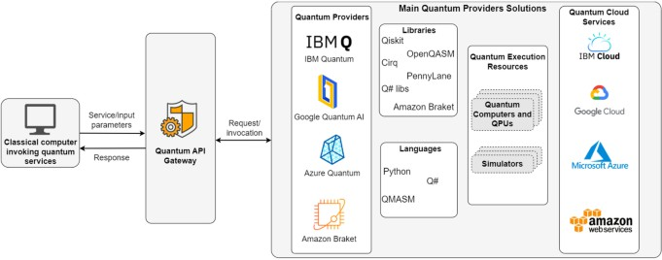

# Here's a more detailed comparison:

1. **Superconducting Quantum Computing: Qubit Implementation:**

Uses superconducting circuits cooled to near absolute zero to create qubits.

# Advantages:

Mature technology with relatively high qubit connectivity and scalability potential.

# Disadvantages:

Requires extremely low temperatures, which can be challenging and costly. Qubit coherence (stability) can also be a challenge.

# Trapped Ion Quantum Computing:

**Qubit Implementation:**

Traps individual ions using electromagnetic fields and manipulates their internal energy levels.

# Advantages:

High qubit coherence and long coherence times. Qubits can be individually addressed and manipulated.

# Disadvantages:

Qubits are not as easily interconnected as in superconducting systems. Scalability can be a challenge.

# Photonic Quantum Computing:

Qubit Implementation: Uses photons (light particles) as qubits.

**Advantages:** Can potentially operate at room temperature, making it easier to integrate into existing infrastructure. Offers potential for long-distance quantum communication. **Disadvantages:** Qubit manipulation and entanglement can be challenging. Photons can be difficult to control and detect.

|  |  |  |  |  |  |
| --- | --- | --- | --- | --- | --- |
| **Platform** | **Qubit Type** | **Coherenc e Time** | **Gate Speed** | **Scalabilit y** | **Temperat ure** |
| Supercondu cting | Electri cal circuit s | Microsec onds | Fast | Moderate | Cryogenic (~15 mK) |
| Trapped Ions | Atomi c ions | Seconds | Slow | Hard | Room or vacuum |
| Photonics | Light particl es | Long | Varia ble | High (theoretic ally) | Room |
| NV Centers | Electr on spins | Long | Slow | Low | Room |
| Neutral Atoms | Atom arrays | Long | Medi um | High (potential) | Cold (μK range) |

# Superconducting Circuits

Superconducting circuits face theoretical barriers related to critical temperature, current, and magnetic field limits, as well as material properties and decoherence in qubits. These limitations impact the scalability and stability of superconducting quantum computers and other applications.

**Key Theoretical Barriers:**

# Critical Temperature, Current, and Magnetic Field Limits:

Superconducting materials lose their superconducting properties when the temperature, current density, or magnetic field exceeds critical values. These limits are fundamental and must be considered when designing superconducting circuits.

# Material Properties:

Many superconducting materials are brittle, chemically unstable, and challenging to shape, which hinders their integration into complex circuits.

# Decoherence in Qubits:

Superconducting qubits, based on Josephson junctions, are susceptible to decoherence, a loss of quantum information due to interactions with the environment. Impurities in the insulating barrier of Josephson junctions are a major source of decoherence.

# Scaling and Complexity:

Designing and fabricating large-scale superconducting circuits with high qubit counts and low error rates is a significant challenge. This includes issues with wiring, control, and readout of individual qubits.

# Trapped ions

Trapped ions, utilized in quantum computing and other precision measurement applications, face theoretical barriers related to maintaining coherence, achieving high-fidelity operations, and scaling up the number of qubits. These barriers include factors like ion heating, limitations in gate speeds, and the complexity of controlling large numbers of ions.

# 1. Ion Heating and Decoherence:

**Ion Heating:**

Trapped ions can experience heating due to interactions with their environment, including stray electric fields and interactions with background gas molecules. This heating can lead to increased motional energy of the ions, causing them to deviate from their desired quantum states and reducing the fidelity of operations.

# Decoherence:

Decoherence, the loss of quantum information due to interactions with the environment, is a significant challenge for trapped-ion qubits. Maintaining long coherence times (the duration for which qubits can maintain their quantum

state) is crucial for performing complex quantum computations.

# Addressing Heating and Decoherence:

Researchers are developing techniques like laser cooling, sympathetic cooling, and using specific ion species and trap designs to mitigate ion heating and decoherence.

# Photonics, Vision vs. reality: what’s working and what remains elusive, The role of quantum software in managing theoretical complexities

Photonics, a field focused on light, offers a vision of revolutionary technologies, while quantum computing, with its reliance on quantum mechanics, aims to solve complex problems. The reality is that both fields face significant challenges in realizing their full potential, particularly in software and theoretical understanding. While photonics has made strides in areas like optical communication and imaging, quantum computing faces hurdles in scaling up hardware and developing robust quantum software. Quantum software plays a crucial role in bridging the gap between theoretical possibilities and practical applications by enabling efficient computation and managing the complexities of quantum systems.

# Photonics: Vision vs. Reality Vision:

Photonics promises advancements in various fields,

# including:

**Optical communication:** Faster data transmission through fiber optics.

**Medical imaging:** Enhanced diagnostics and treatments. **Quantum computing:** Using photons as qubits for computation.

**Sensors:** Highly sensitive and precise measurement devices.

# Reality:

While photonics has seen significant progress, several challenges remain:

**Scalability:** Developing large-scale photonic integrated circuits is complex.

**Integration:** Combining photonic components with other technologies can be difficult.

**Cost:** Manufacturing sophisticated photonic devices can be expensive.

**Quantum teleportation:** Experimental demonstration of on-chip CNOT gate teleportation is still a research frontier.

# Quantum Computing: Vision vs. Reality Vision:

Quantum computing aims to solve problems currently intractable for classical computers, such as:

**Drug discovery:** Simulating molecular interactions for new drug development.

**Material science:** Designing new materials with desired properties.

**Cryptography:** Developing more secure encryption methods.

**Financial modeling:** Optimizing investment strategies.

# Reality:

**Hardware limitations:** Building stable and scalable quantum computers is a major challenge.

**Error correction:** Quantum systems are susceptible to noise and errors.

**Software development:** Creating efficient and reliable quantum algorithms and software is crucial.

**Quantum chasm:** The transition from small-scale to large- scale quantum computers is a significant hurdle.

# The Role of Quantum Software

Quantum software plays a critical role in translating human- understandable instructions into operations on quantum hardware.

# Converting classical instructions:

Quantum software needs to bridge the gap between classical programming languages and the unique requirements of quantum computers.

# Managing complexity:

Quantum systems are inherently complex, and software is needed to manage superposition, entanglement, and other quantum phenomena.

# Enabling hybrid systems:

As quantum computers become available, software will be needed to integrate them with existing classical systems.

# Developing quantum algorithms:

Designing efficient and robust quantum algorithms for various applications is a major research area.

# Testing and debugging:

Quantum software requires specialized tools and techniques for testing and debugging quantum code.

# Specific examples of quantum software challenges and potential solutions:

**Classical-quantum interface:**

Developing robust software to translate between classical and quantum computing environments is essential, according to a paper on **arXiv**.

# Quantum algorithms for chemistry:

Developing software that allows chemists to perform computations on molecular systems without needing to understand the intricacies of quantum hardware is a major goal.

# Quantum software engineering:

Research into quantum software engineering methodologies is crucial for building reliable and maintainable quantum software.

# Quantum simulators:

Quantum simulators, like IBM Qiskit Aer, are valuable tools for testing and debugging quantum code before deploying it on actual quantum hardware.

In conclusion, both photonics and quantum computing hold immense promise, but realizing their full potential requires addressing significant challenges in hardware, software, and theoretical understanding. Quantum software is key to unlocking the power of quantum computing and integrating it with existing classical systems.